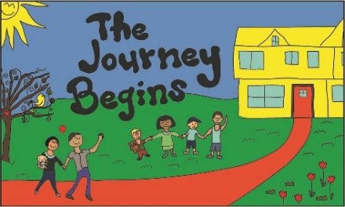

I give The Journey Begins staff permission to administer

Sunscreen_________________________ and/or Insect Repellent _________________
Brand Brand

to my child ___________________________ before outside play time. Name

I have brought the repellent from home and labeled it with my child’s name; I take full

responsibility for any adverse reactions my child may have as a result of this/these

products.

__________________________________ _______________________
Signature Date

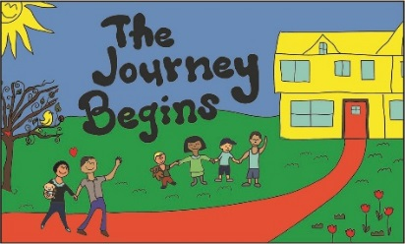

I give The Journey Begins staff permission to administer

Sunscreen_________________________ and/or Insect Repellent _________________
Brand Brand

to my child ___________________________ before outside play time. Name

I have brought the repellent from home and labeled it with my child’s name; I take full

responsibility for any adverse reactions my child may have as a result of this/these

products.

__________________________________ _______________________
Signature Date

